ESSENTIAL DB OPERATIONS IN CHROMADB

How to create collections:
- Collections are like table in a regular db. But instead of storing structured data in a row and column, Each entry usually contains:
- id
- embedding (vector)
- metadata (like JSON)
- sometimes document/text
In order to create a collection:
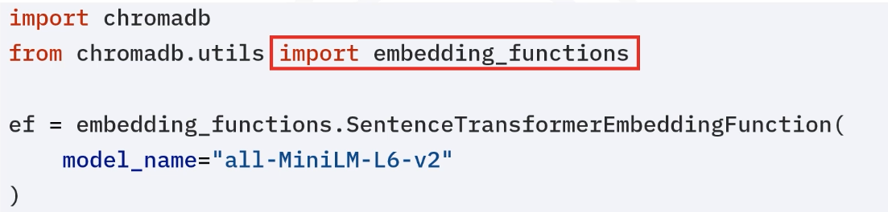
Then, you define the chromaDB client..
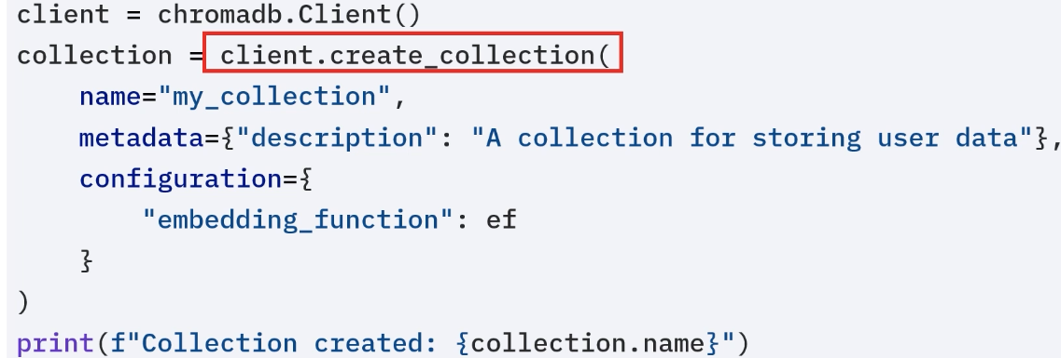
In order to connect to a connection already created:
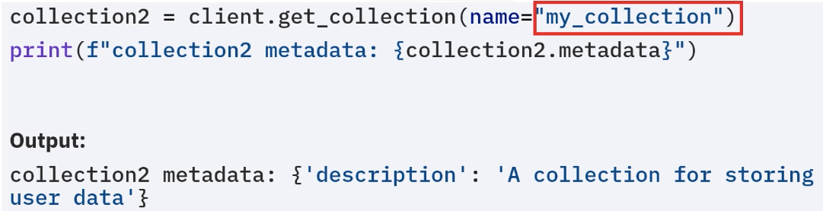
To modify a collection:
